Exercise 1. Choose the correct words :
1. Put on your sweater. It is very cold/hot today.
2. It is rainy/sunny today. Take the umbrella.
3. Let’s go to the beach. It’s very hot/rainy.
4. It is cloudy /sunny today. It may rain.
5. It’s snowy/ hot today. Let’s make a snowman.
6. The wind is cold/hot . Don’t catch a cold.
7. The weather is windy /cloudy today. Take your umbrella.
8. The weather is bad /nice/. Let’s go for a walk.
9. I like this weather. It is sunny and cold. /warm.
Exercise 2. Write the season : spring summer autumn winter
a)I like …………………  It is hot and sunny.  I go on holiday | b)I like …………………  It is very cold.  My children play in the snow. | c) I like ……………….  It is not very cold.  I like the flowers.  . | d) I like ……………………  The children go back to school.  The leaves fall from the trees.

Exercise 3. Look and read . Choose the correct picture A or B. 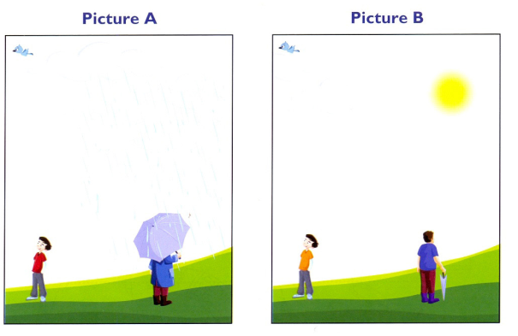
purple boots
red T-shirt
1.There are three clouds in the sky. A
2.It’s nice , sunny weather. _______________
3.The man is wearing purple boots. _______________
4.The man’s umbrella is open. _______________
5.The boy is wearing red T- shirt. _______________
6.The man is wearing blue coat. _______________

